**PF Lab Assignment 10**

## **Question 1:**

**Code**

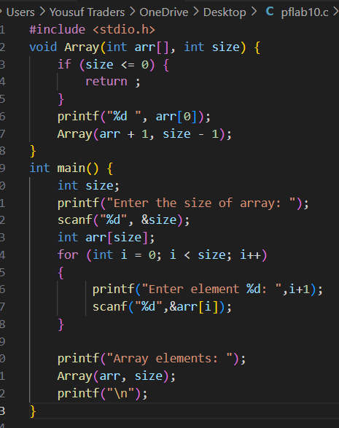

**Output**

**Question 2:**

**Code**

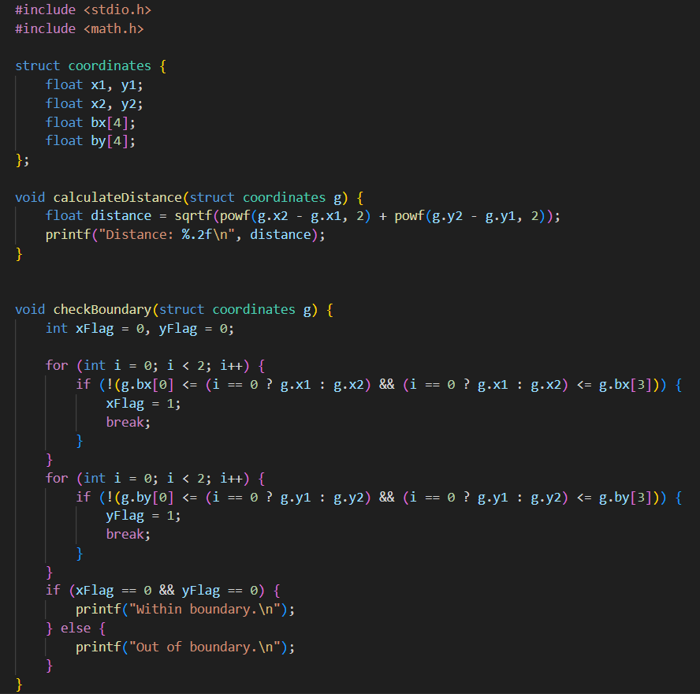

**Output**

**Question 3:**

**Code**

**Output**

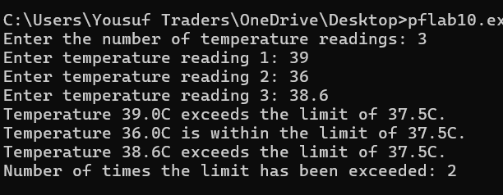

**Question 4:**

**Code**

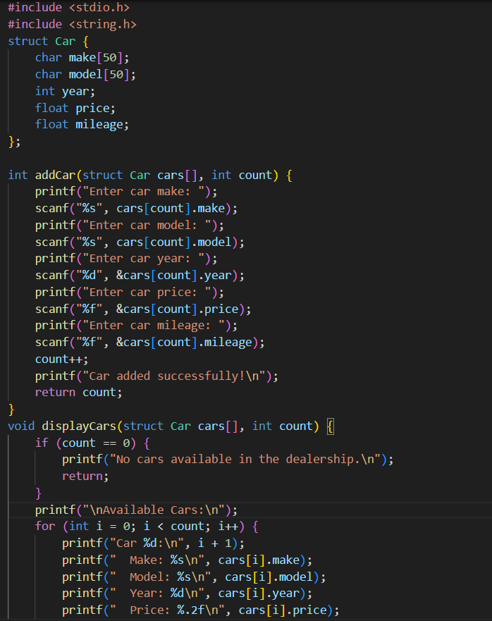

**Output**

**Question 5:**

**Code**

**Output**

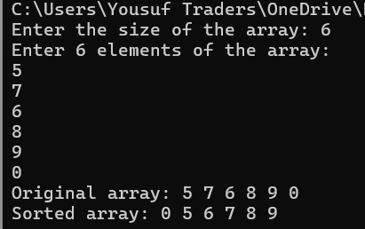

**Question 6:**

**Code**

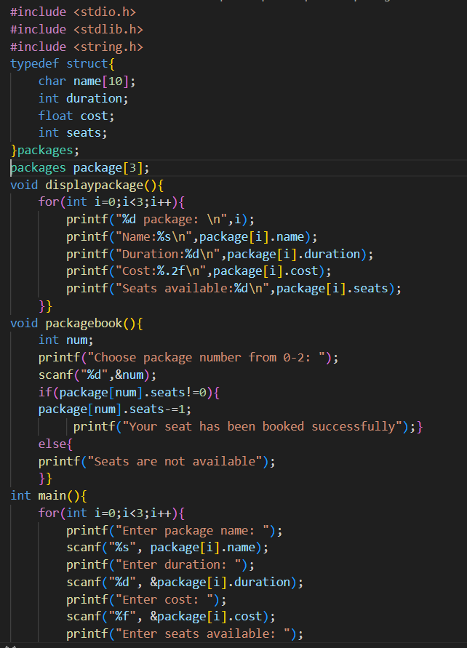

**Question 7:**

**Code**

**Output**

**Question 8**

**Code**

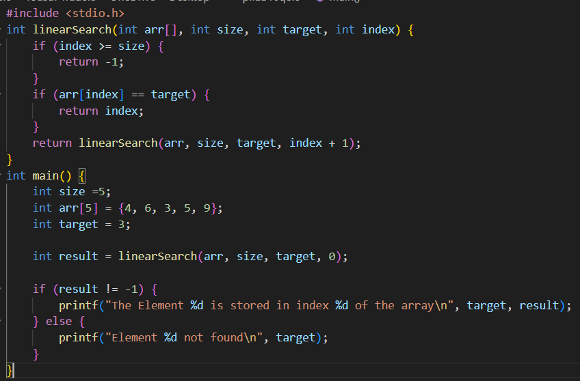

**Output**

**Question 9**

Write a recursive function that calculates the sum of digits of a number. For example, if the input is 123, the output should be 6.

**Code**

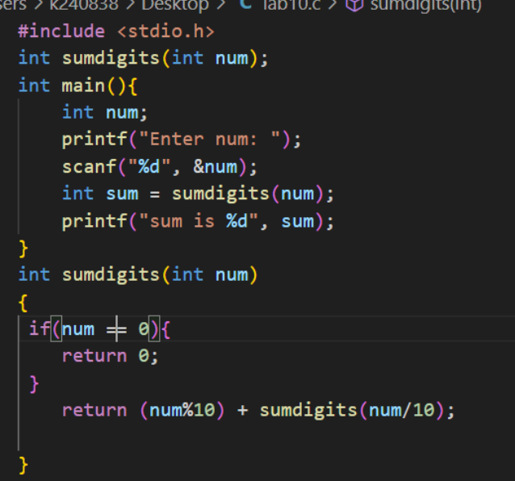

**Output**

**Question 10**

**Write a recursive function that takes a string as input and returns the reversed string.**

**Code**

**Output**

